Most Trendline Breakouts Are Noise — Only Breakout Quality Matter
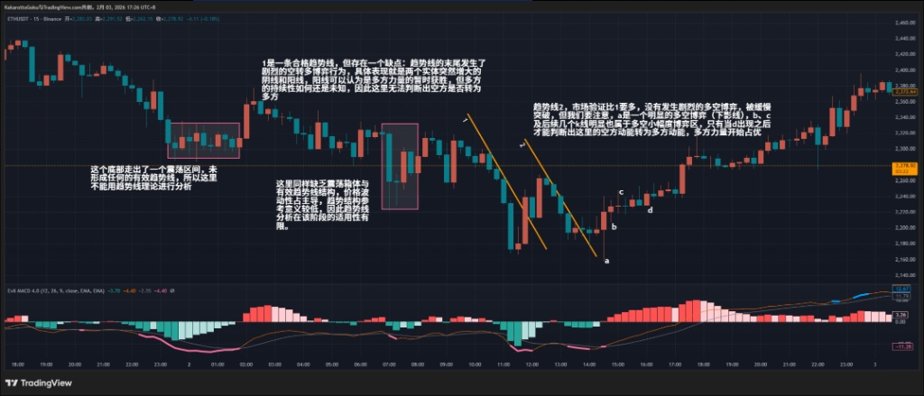
Many traders draw trendlines and only care about whether price breaks them.
But what actually determines win rate is the quality of the breakout.

1 BTC

Along Trendline 1, price breaks upward at point a.
Candle a has an upper wick, but the wick does not exceed the body. This can still be considered a valid breakout confirmation. However, what really matters is what happens after — b, c, and d represent clear buyer–seller battles.
If entering at a, protective stops should be adjusted quickly according to evolving structure. Eventually, e represents the local peak of bullish momentum in this sequence.
Price later breaks Trendline 2 at f. But f requires caution. Compared to a, this is a weak breakout: the close is extremely close to the trendline and only slightly above it. This makes the breakout quality very low — it cannot be treated as strong bullish participation. The breakout at g is also weak.
Another strong-looking breakout appears at h, but it has two issues: 1) It runs into the same strong resistance faced at f, 2) The candle body expands abruptly — momentum sustainability is uncertain.
Trendline 3 is newly formed and has not been validated by the market (at least one retest is needed). Therefore, any breakout here has even less structural meaning and may simply be short-term volatility rather than true market consensus.
Trendline 4 is different — it has market validation and is strongly broken at k. But k shares the same flaw as f: the candle body expands too abruptly, making continuation uncertain. If stop loss is placed at recent swing lows, the risk distance becomes too large. This breakout is structurally inefficient and best avoided.
Finally, Trendline 5, which has been validated multiple times, is broken upward at P. The wick structure at P is acceptable, and for the first time we see: bearish momentum weakening and bullish participation increasing.
Among multiple breakout attempts in this zone, P shows the best breakout quality in terms of closing position and wick structure.
Conclusion (BTC): The highest-quality bullish signal is not the earliest breakout, but the one that occurs after repeated market validation — point P.

2 ETH
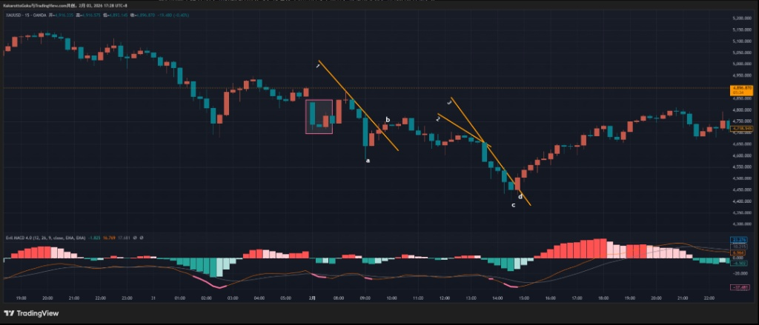
We first observe a bottom consolidation zone (pink box). This area forms a range structure without valid trendlines, so trendline analysis does not apply.
Another consolidation follows, still lacking clear structure. Price volatility dominates, making trendline logic unreliable during this phase.
Eventually, Trendline 1 forms — it is technically valid, but has a flaw: at its end, we see violent buyer–seller battle behavior, shown by two large opposite candles. The bullish candle may signal temporary buying strength, but sustainability is unknown. We cannot yet confirm a shift from bearish to bullish control.
Later, Trendline 2 forms with more market validation and smoother price behavior. It is broken gradually, but we must note: a shows clear battle (long lower wick), while b, c, and subsequent candles remain in minor conflict.
Only when d appears do we see confirmation that bearish momentum has transitioned into bullish momentum.
Conclusion (ETH): The structure only completes its bearish-to-bullish momentum transition after d, not during earlier breakout attempts.

3 Gold

We first see a box range (pink zone). Ranges represent short-term consolidation, so trendline analysis is not appropriate here.
Trendline 1 is broken at b, but bullish momentum is not yet established. Comparing candles a and b, bearish momentum at a is clearly stronger than bullish strength at b. Continuation probability remains questionable.
A pullback forms Trendline 2, but it is quickly invalidated, leading to a steeper Trendline 3.
When candle d breaks Trendline 3, the situation changes: comparing c vs d, bullish momentum at d is clearly stronger. This is a much higher-quality momentum shift than the earlier signal at b.
Conclusion (Gold): The true momentum-based reversal confirmation occurs at d, not at the earlier false signal at b.

🔥 Final Principle
Trendlines themselves are not the edge. The edge comes from:
• How many times the structure is validated by the market
• The quality of the breakout candle
• Whether follow-through structure supports the move
Otherwise, most breakouts are just noise.

